Bedford Community Christmas Station

Shoes for Students

Application for Assistance

2024



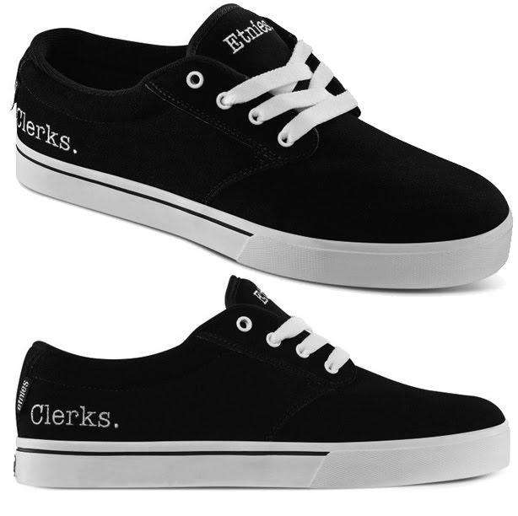

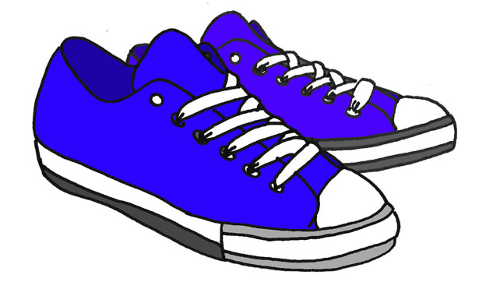

Name of Parent/Guardian: _________________________________________________________________

Address: __________________________________________________________VA________________________

Street City VA Zip

Home/Cell Phone: ______________________________ Email Address:_______________________________

Child’s Name: ________________________________________________ Date of Birth: ________________

First Middle Initial Last

Gender: __________________ Shoe Size: ***______________ Adult Child Toddler

** ½ sizes will be rounded up to nearest full size.

Name of School: ______________________ Grade:_________________

Child’s Name: ________________________________________________ Date of Birth: ________________

First Middle Initial Last

Gender: __________________ Shoe Size: ***______________ Adult Child Toddler

** ½ sizes will be rounded up to nearest full size.

Name of School: ______________________ Grade:_________________

Child’s Name: ________________________________________________ Date of Birth: ________________

First Middle Initial Last

Gender: __________________ Shoe Size: ***______________ Adult Child Toddler

** ½ sizes will be rounded up to nearest full size.

Name of School: ______________________ Grade:_________________

Child’s Name: ________________________________________________ Date of Birth: ________________

First Middle Initial Last

Gender: __________________ Shoe Size: ***______________ Adult Child Toddler

** ½ sizes will be rounded up to nearest full size.

Name of School: ______________________ Grade:_________________

Child(ren) must be attending a Bedford County Public School in Headstart through grade 12 or be registered with BCPS as a homeschool student to be eligible. Proof of enrollment in BCPS or approval for homeschooling is required at screening. *You must have physical and legal custody of each child that you list on this application and the child must be living in your household.* Picture id, proof of household income, and proof of residence is also required. Students who meet the above criteria, whose families who received Christmas assistance through the Christmas Station in December 2023, are approved for the shoe program however, registration is required. Registration will be held on Saturday July 13th from 2pm to 4pm and Thursday July 18th from 11am to 1 pm. Late applications will not be accepted. Shoes cannot be exchanged or returned.